The Minneapolis St Paul District will hold its annual conference from April 20th to April 22nd. At the seat of this conference, we will have a huge retirement celebration of Presiding Elder and Mrs. Reff.

WHERE: Doubletree St Louis Park, 1500 Park Pl Blvd, Minneapolis, MN 55416
WHEN: Friday, April 21, 2017, 7pm
WHAT: A worship service and reception in honor of our Presiding Elder Alphonse Reff, and Mrs. Janice Reff. The Right Reverend John Franklin White, Presiding Bishop and President of the Council of Bishops of the A.M.E. Church, will be our special guest preacher.
For more information about the celebration, please contact Reverend Stacey L. Smith, St. James A.M.E. Church Tel: 651-227-4151 Cell: 952-261-9135

District Conference Special Room Rates have been reserved: April 20 - April 22 from $140.00 USD at the Doubletree Hotel located 1500 Park Place Blvd., Minneapolis, MN Tel: 952-542-8600-Fax: 952-524-8063
Reservation deadline: March 30, 2017
To reserve a hotel room, please call 800-259-9190 and use group code: PRT - St. Paul/Minneapolis District.

Spiritual Transformation Convocation 2017
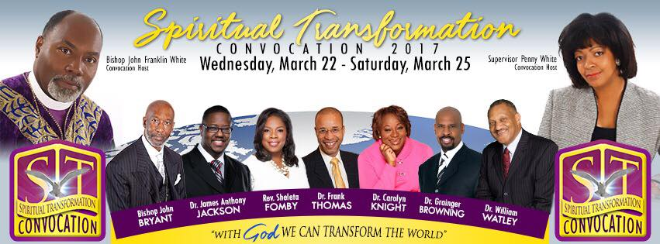
Greetings in the precious name of Our Lord and Savior, Jesus Christ! I am excited to invite you to the Fourth District’s inaugural “Spiritual Transformation Convocation” (formerly Mid-Year Convocation). This momentous event will take place on Wednesday, March 22 through Saturday, March 25, 2015, at the Wyndham Indianapolis West Hotel, 2544 Executive Drive, Indianapolis, IN. Our theme is: WITH GOD, WE CAN TRANSFORM THE WORLD; WITH GOD…ALL THINGS ARE POSSIBLE (Matthew 19:26).
Please note the following format. On Wednesday, Stakeholder groups will meet in the afternoon and our Opening Worship Communion Service will start at 7:30pm. On Thursday and Friday, we will participate in inspiring plenary sessions, edifying workshops and spirit-filled worship services, with specialty sessions for clergy, lay and young adults. We will close on Saturday with a morning plenary session. The planned speakers, facilitators and preachers are renowned leaders who will impact our 4th District ministries in a spiritually, powerful way.
I am praying for revitalized churches with renewed strength and re-energized commitment for our district. Please pray with me as we join together at this convocation to experience a covering of God’s power that will allow our ministries to “Spiritually Transform the World”. If you have any questions, please do not hesitate to contact Ms. Jo Ann Hawkins White in the Fourth District Office at 773.955.9825.
God Bless!
Bishop John Franklin White and Episcopal Supervisor Penny Hartstfield White

